//Opener Building on Areas of Agreement
We all know how terrible the feelings is when getting some ache, like headache, stomachache, and so on and so forth.
And what the feelings is for those patients with serious and incurable disease.
As a terminal cancer patient describe, every time I wake up, there seem to be millions of ants are gnawing on my cells.
What a horrible scene is! We mustn’t be able to endure the pain once, not to mention, you need to suffer the torture every day!!!
But, every patients as above need to accept the expensive treatments.
And what we prolong is a meaning life or endless pain?
Sadly to say, the purpose of the treatment is not to cure the illness because that’s no possibility to get well .
All we can do is lie on the bed and look at our body becoming weaker and weaker until we die.
Suddenly, if the god appears, and give you a bottle of drink can relieve your great pain, all you need to pay is just your life, will you drink off it?
I will.

//Statement of Persuasive Claim
So today, I would like you to consider euthanasia when you cannot endure the pain of terminal diseases anymore.

//Preview
I’m going to persuade you to support euthanasia from these three aspects.
First, we need it.
Second, we want it.
And third, we can control it.

//Transition
So to begin, let’s look at why we need it.
Many of you might be skeptical about euthanasia because you are not those terminal-illness patients. You will be amazed to learn that there are many patients waiting for death and the continuity of life is another kinds of torture for them.

//BODY
When it comes to euthanasia, I think 傅達仁 this name will struck to our mind.
傅達仁 is a terminal cancer patient, just as other patients suffered from the serious pain, he was tortured by the illness every day.
But why he become so famous in Taiwan? Did he overcome the serious disease? Or did he find the way to cure the cancer?
No, he didn’t fight with diseases, but fly to Switzerland to receive the euthanasia instead.
For those tortured by the diseases, life is full of desperation, and the death
is only way to be rescued.
So by the example of 傅達仁, we would like to show you that allowing people to ‘die with dignity’ is kinder than forcing them to continue their lives with torture.

//Transition
Let’s move on to the next point, “why we want it”.
Or exactly, “why we want to choose when to die”?
Why many people are afraid of death? Because there are many things they haven’t do yet, However, if you are lying on the bed, accepting the treatments, you may not know whether you have the chance to accomplish your hopes.

//BODY
For a cancer patient, treatments not only spend lots of time and money, but also take much energy and the power of spirit.
There are many people are too weak to finish their hopes, why not taking action when you have enough energy and time.
After you know how much time you have, you will cherish the time rather than receive those treatments in vain.
Undoubtedly, you may miss the miracle to get well, but more importantly you can finish what you want, and accomplish with the one you love before you pass away. I think it’s more meaningful than waiting for the miracle until you die.

//Transition
Finally, the reason you might refuse the euthanasia is that you worry the negative effect of it . like promoting suicide, or abusing euthanasia.
You will be very pleased to learn that euthanasia is in fact very well-ordered in other countries.

//BODY
Since the standard of euthanasia is higher than it. The fundamental standards of the euthanasia are at least incurable illness, unbearable pain. And the most important thing is that the patient should accept the euthanasia when they’re awake. None of others has the authority to represent the patient.
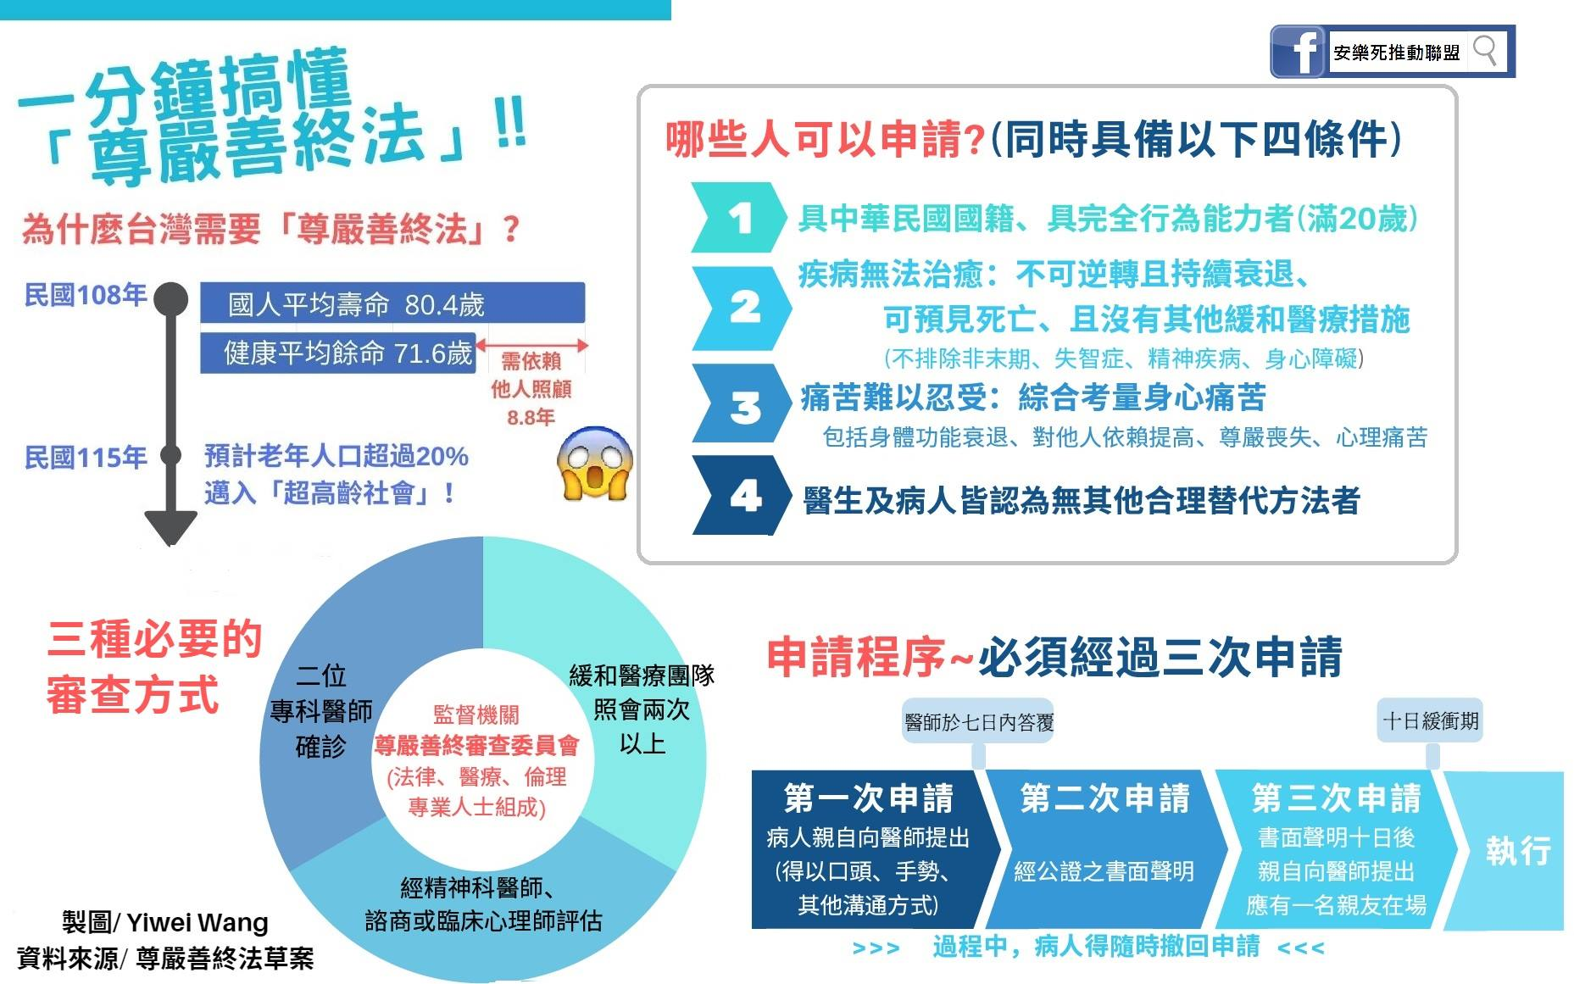

//Summary
Today, you are healthy, able-bodied, and hopeful of the future.
But, there’re lots of people tortured by their diseases.
They are hopeless to the future.
No one want to leave the world when they are able to change.
Unfortunately, those patients are too weak to struggle.
Those who are volunteer to receive the euthanasia are not the cowards to escape from life. On the contrast, they are heroes to face the death.
They need euthanasia. They want euthanasia.
And please believe in us, we can control it. Positive effect of euthanasia is more than the negative effect.
Euthanasia offers a better way to leave the world peacefully.

//Memorable Concluding Remarks
Now we realize that the execution of the euthanasia is a new road for those tortured by the diseases many years ago.
So support the euthanasia to be legal in Taiwan, give them a way to leave peacefully.
Finally, Hope we never need it, but be glad the option, the euthanasia, is there.

